
St. Mary’s d’Youville Pavilion
June 2020
Therapeutic Recreation Department
* 102 Campus Ave Lewiston ME 04240 * (207)-777-4200 *
June 2020  Informational Corner  What’s Happening  Special Functions  Therapeutic Recreation Department  Shelly-Director Recreation Therapy  Jessica-Recreation Therapist  Karen-Activity Coordinator, TAC  Cassie-Activity Coordinator | Informational Corner  

What’s Happening  ZOOM & FACETIME    We are continuing to do ZOOM and FACETIME calls for our resident’s.  If you would like to talk to your loved one please contact Shelly at 777-4461 or email at skatula-blais@covh.org  You may also contact the Unit Managers on all units. They can be reached by calling 777-4200.  June 2020 |  | We now have Telemedicine for our Residents with:  Nephrology  Neurology  Cardiology  Oncology  Psychology  Counseling  Memory Care Clinic  Wound Care Clinic  
Special Functions  Father’s Day Meal for Resident’s!  Lunch:  Steak & Shrimp  Baked Potato  Prince Edward Island Bland  (Wax Beans, Green Beans, Carrots)  Strawberry Cheesecake  Lemonade  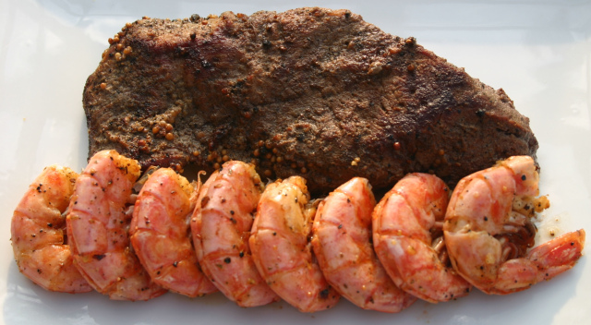  June BBQ’s for Residents!  Week of June 22nd  Menu:  Hamburgers  Chips  Macaroni Salad  Strawberry Shortcake  Ice Tea  June 2020 | BeSafe Bingo Continues!  If the Resident wins the game they get to pick a special meal.  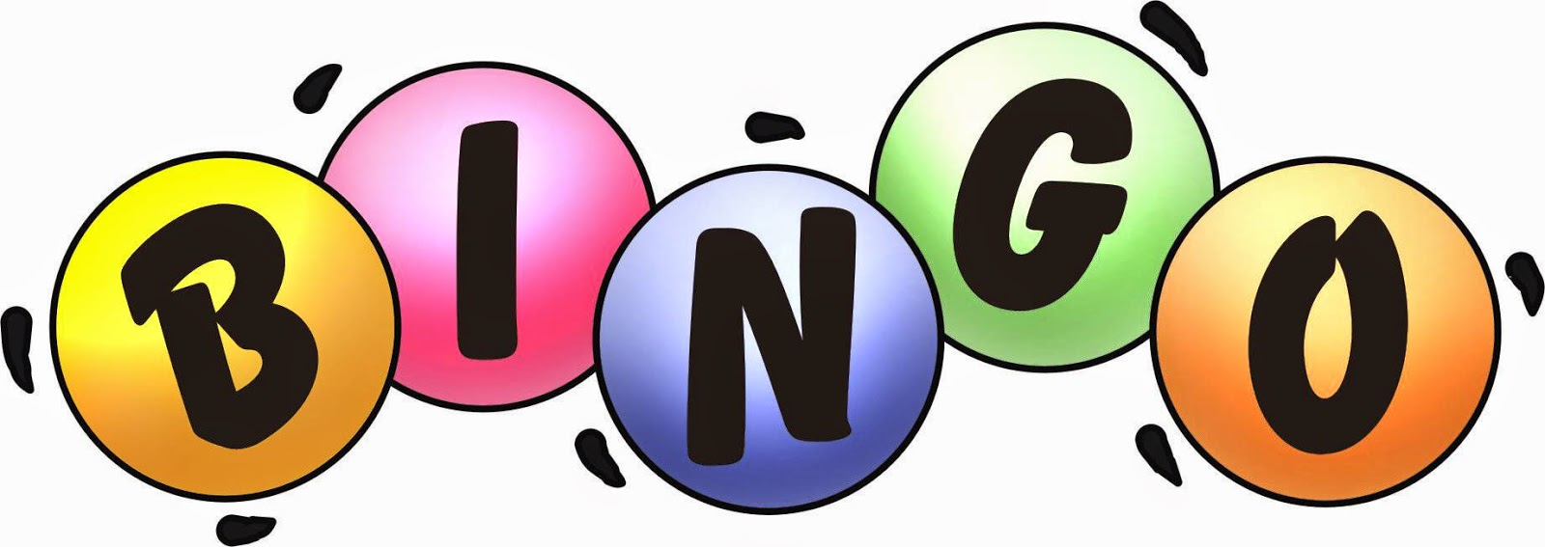  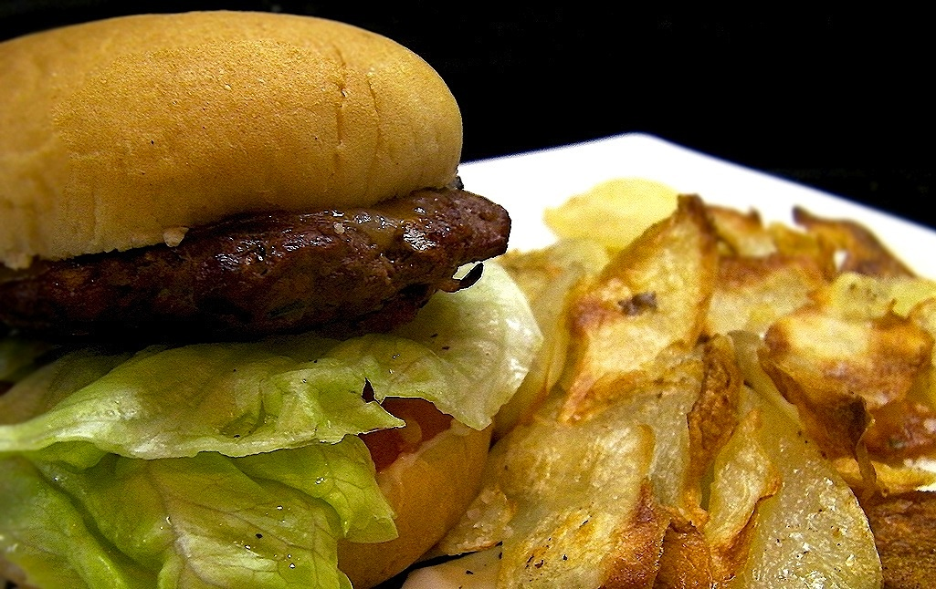
Postage
Information
Your Mailing Address
Street Number and Name
City, State ZIP Code
Stay Safe, Wash your Hands, and Wear a Mask!   | 
Your Return Address
Street Number and Name
City, State ZIP Code

